Equation | Graph
Given the function:  f(x) = x⁴ – 8x² + 7  Determine  f’(x) =  f”(x) = | 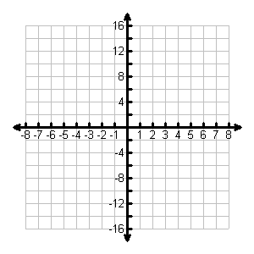
Table | Analysis
- Determine the average rate of change (ARoC) of f(x) over the interval [0, 2].

- Graph f’(x) on the axes above.

- Determine the equation of the tangent line of f(x) at x = -1.

- At what point(s), if any, are the tangents to the graph of f(x) horizontal?

- When is f’(x) > 0? When is f’(x) < 0? What does the value of f’(x) tell you about the graph of f(x)?

- Determine the point(s) on f(x) where f”(x) = 0.

Connecting and Communicating What We Know About the Derivative of a Function

